**1. Introduction to Ingress Internal ALB**

--- in this section, we are going to create the internal application load balancer using Kubernetes

Ingress Manifest.

**Ingress ALB internal load balancer**

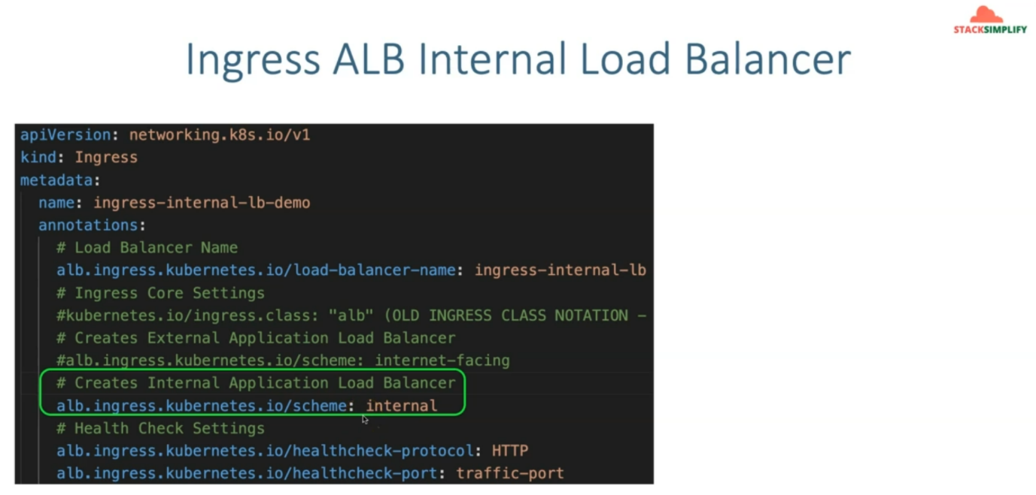

--- to do so, we are going to use the scheme, scheme annotation as internal.

--- if you remember so far, the internet facing related load balancer to create, we have provided the

scheme as internet facing. now we will comment that part and add the scheme as internal so that it will create the Ingress ALB internal load balancer.

**Curl pod**

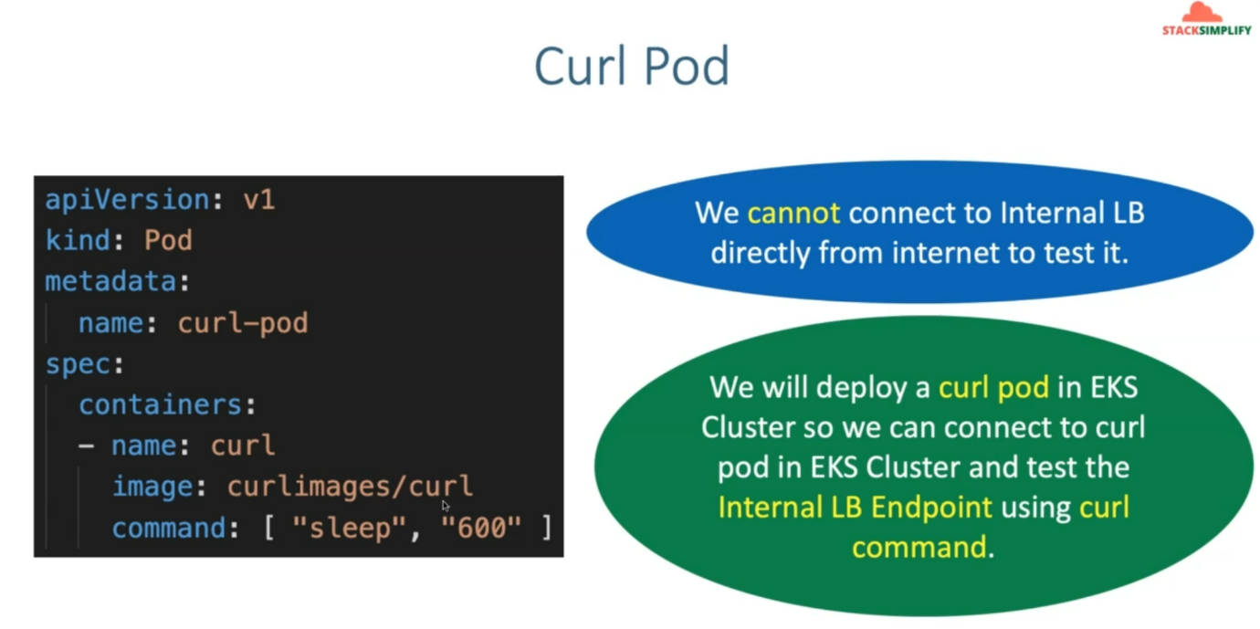

--- to test this internal load balancer. So, we cannot connect to internal ALB directly from internet to tested.

--- So, to do that, we will deploy a curl pod in EKS cluster so we can connect to curl pod in EKS cluster and test the internal Alb endpoint using this curl command.

**Series of command for testing**

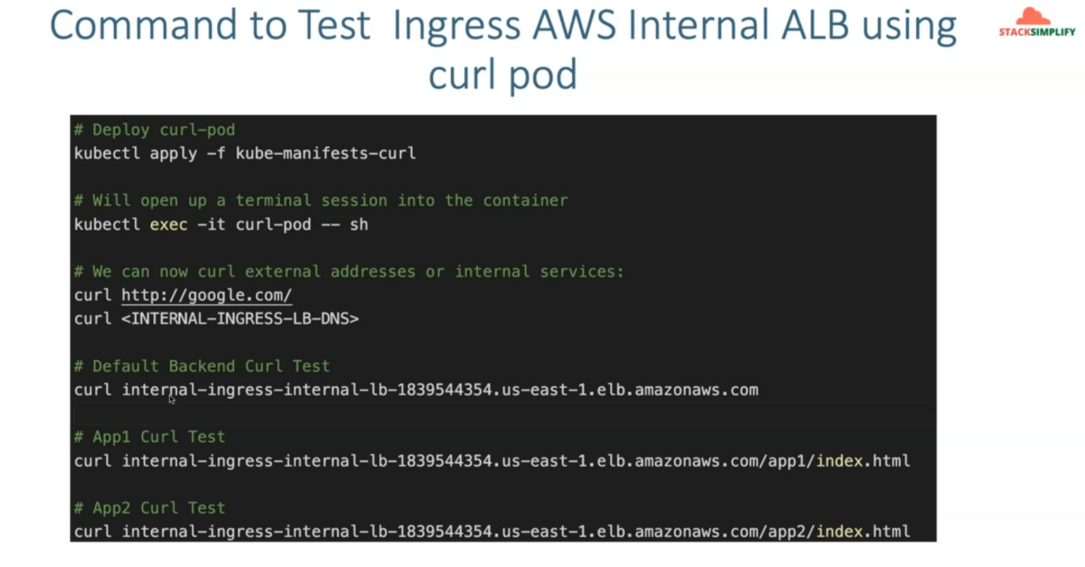

--- these are the series of commands we are going to use for curl testing.

--- first, we will deploy the curl pod and using the kubectl Command, we will connect to that respective to curl pod and from curl pod, we will be able to run the curl commands.

--- So, we will run the curl command for our default backend related use case and also for app1 curl test and also for app2 curl test.